TO SUPPLY LEFTOVER FOOD TO POOR

College Name : Sasurie College of Arts and Science

College Code :bru5y

TEAM ID : NM2025TMID25203

**TEAM MEMBERS :**

Team Leader Name : S.Udhaya Krishnan

Email : [udhayakrishnan782005@gmail.com](mailto:udhayakrishnan782005@gmail.com)

Team Member1 : V.Naveen Kumar

Email : [nkumarv112@gmail.com](mailto:nkumarv112@gmail.com)

Team Member2 : P.Manikandan

Email : [mk7472321@gmail.com](mailto:mk7472321@gmail.com)

Team Member3 : M.Gokul

Email : [gokulmanikandan202@gmail.com](mailto:gokulmanikandan202@gmail.com)

**INTRODUCTION**

Hunger and malnutrition remain one of the biggest challenges in society. Millions of people, especially those living in poverty, struggle daily to meet their basic food needs. Supplying food to the poor is not only a social responsibility but also a step toward building a healthier and more equitable community. This project focuses on creating effective systems and initiatives to provide nutritious meals to underprivileged individuals and families.

**OVERVIEW**

Objective: To ensure no person sleeps hungry by supplying affordable or free food to poor and homeless people.

Target Group: Slum dwellers, daily wage workers, street children, homeless individuals, and families living below the poverty line.

Methods:Establishing food banks and community kitchens.

Collecting surplus food from restaurants, hotels, and households.

Partnering with NGOs, government schemes, and volunteers.

Distributing dry ration kits and ready-to-eat meals.

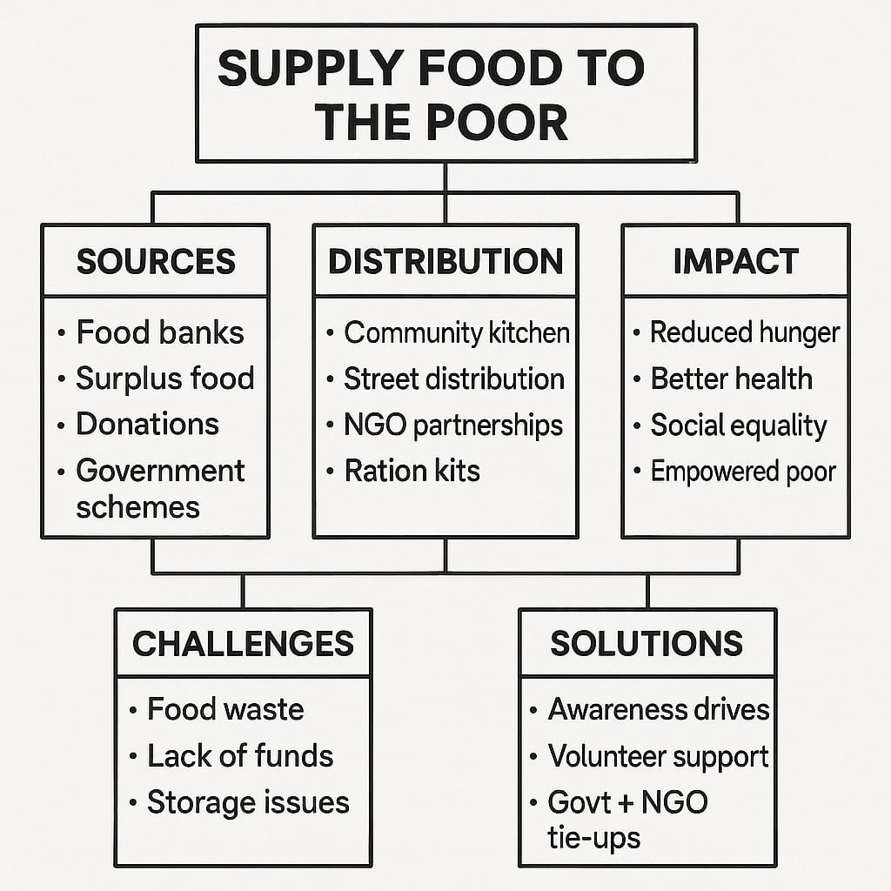

* Salesforce Developer Account Creation

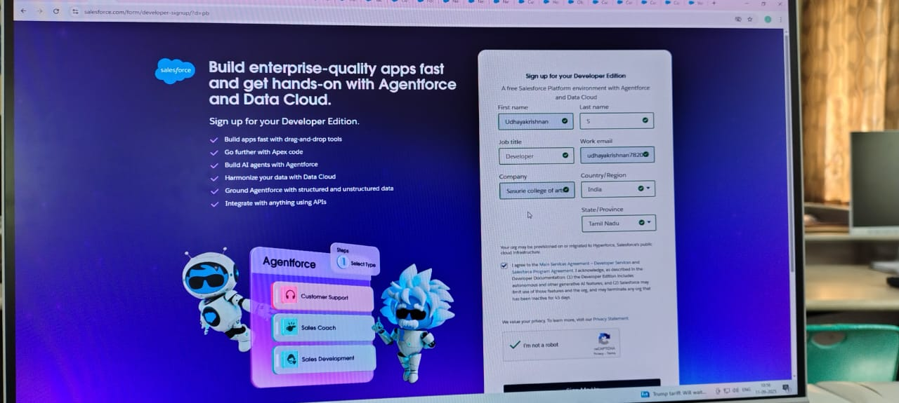

* User detail
* Public groups

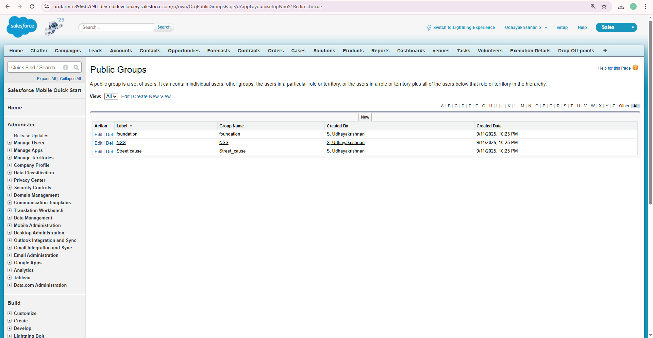

* Creation of User

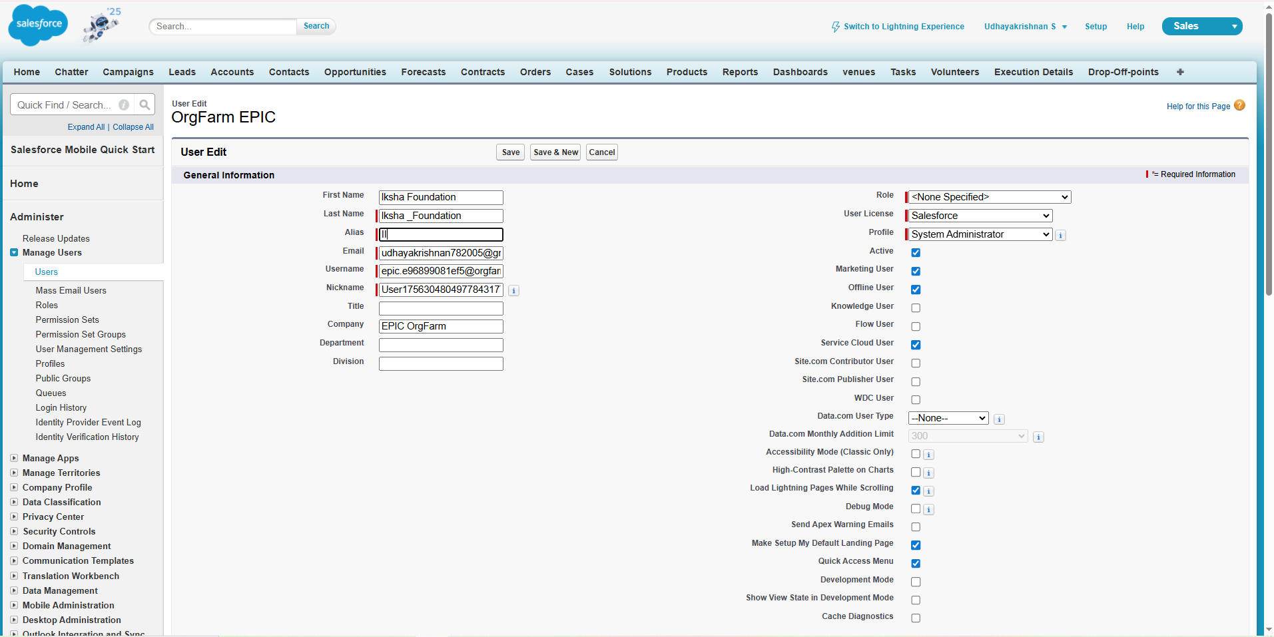

* Creating a Custom tab

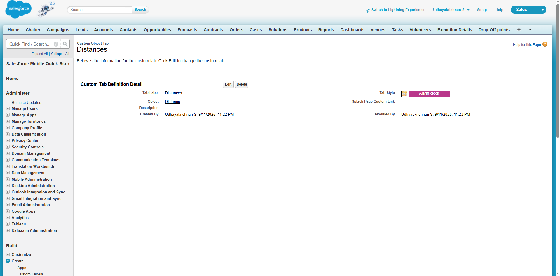

* Apex Trigger Details

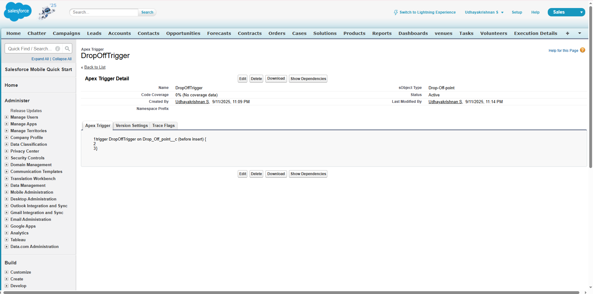

* Standard platform user

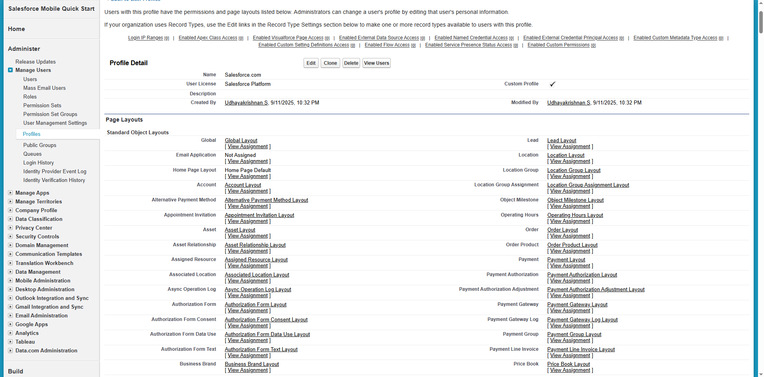

* Page Layout assignments

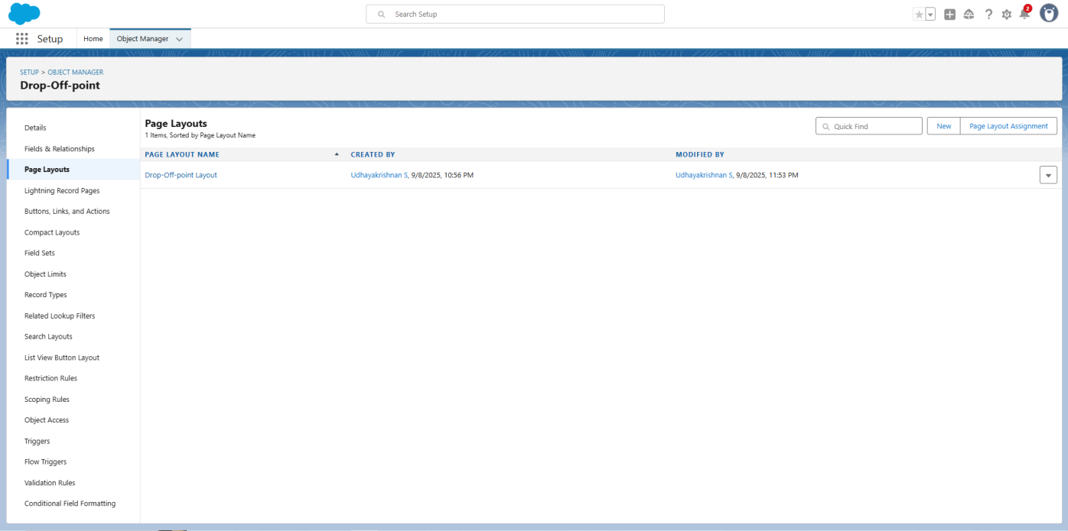

* Creation of Public Group



* Creating a Custom Tabs
* Custom Report types

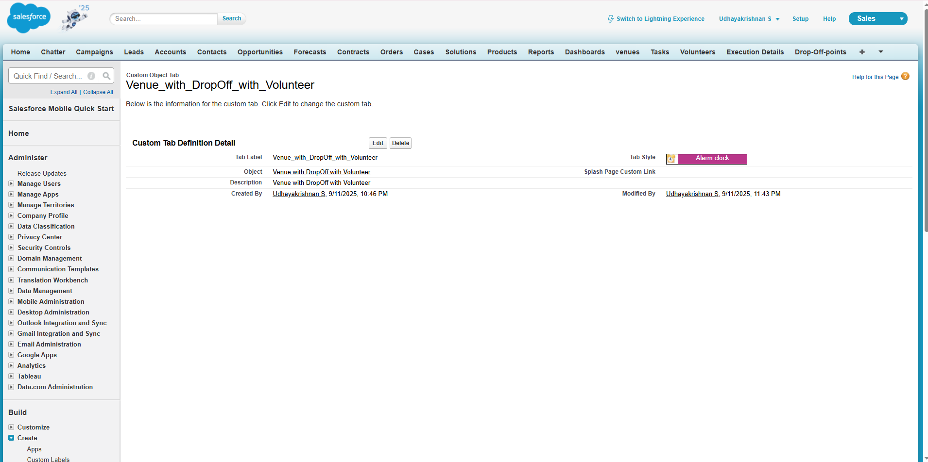

* Ligjtning Experience App Manager

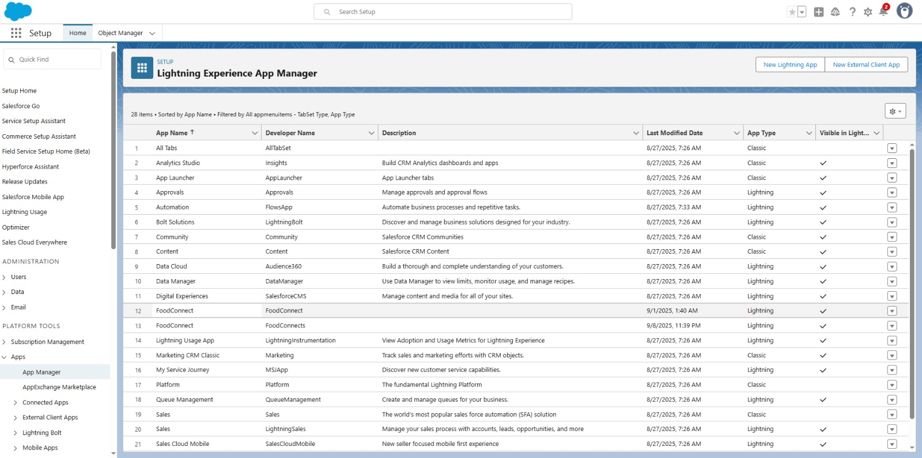

* Creation of Home page

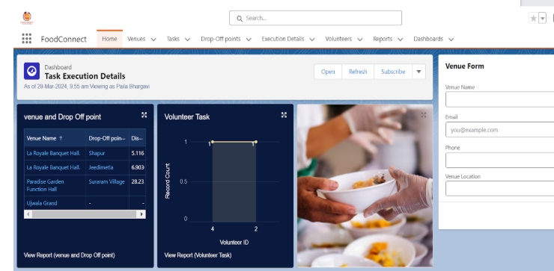

* Object Manager

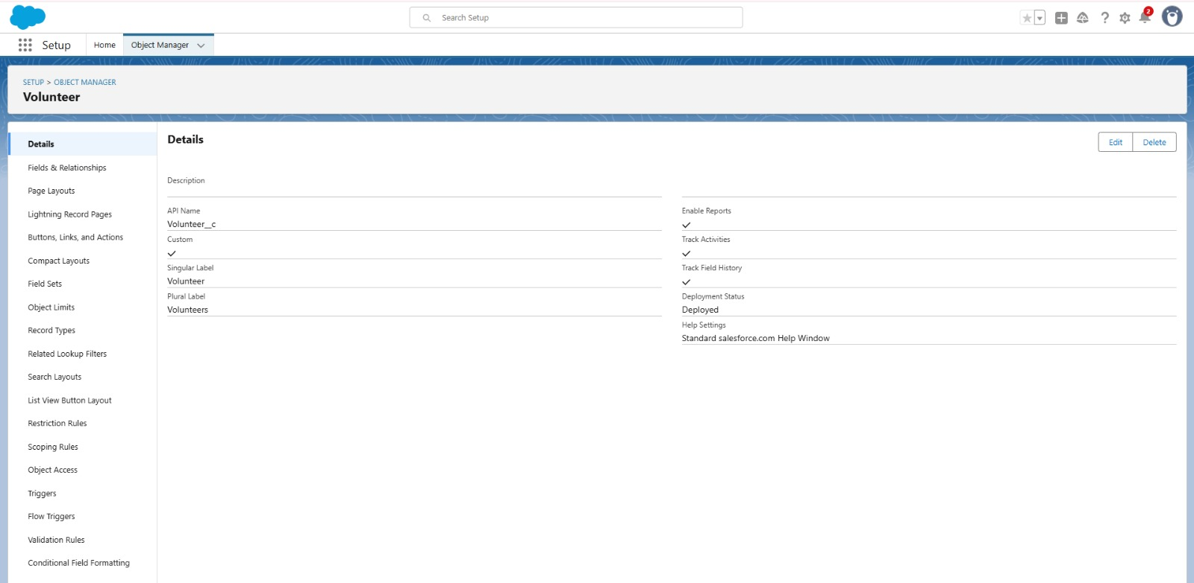

* Drop of Point

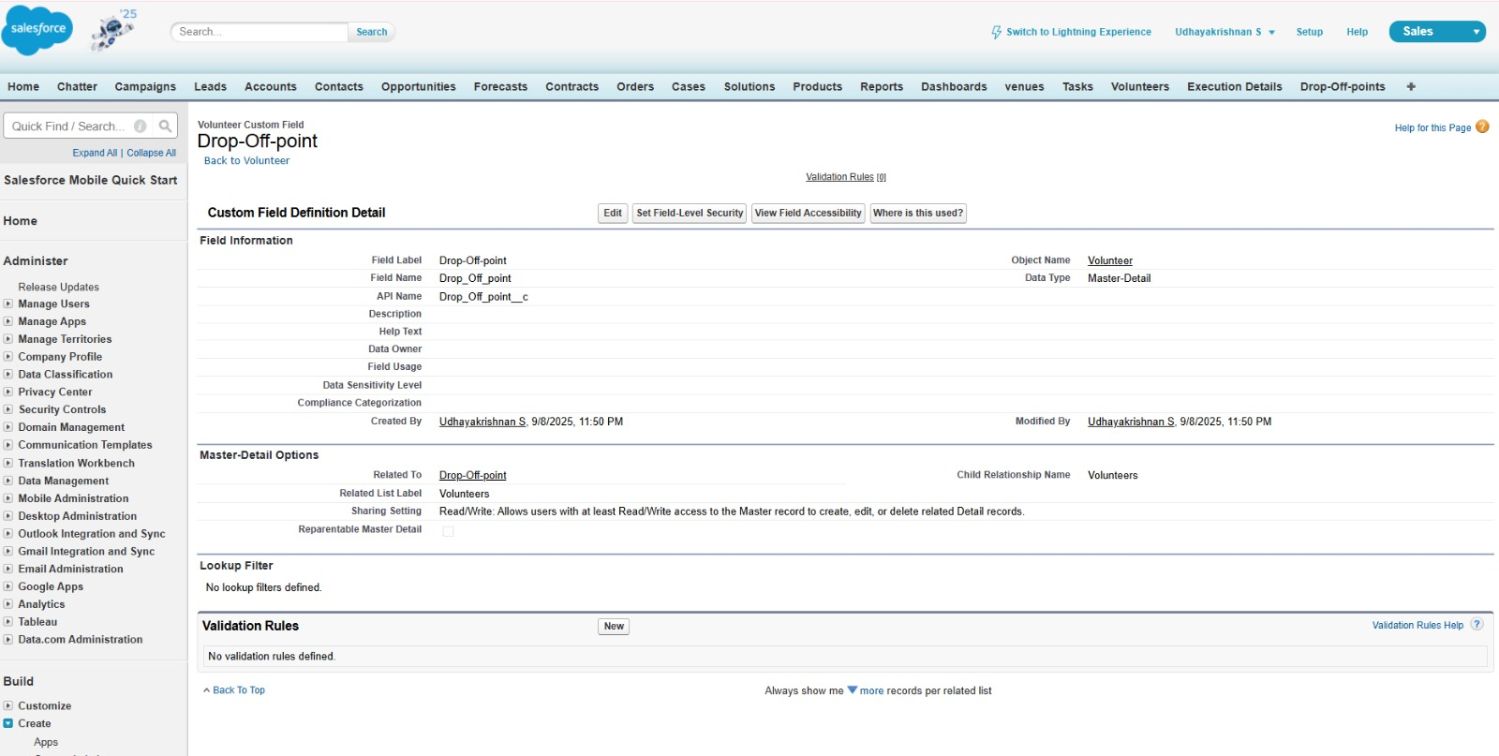

* Execution Details

==

* Creating a Trigger

Code:

trigger DropOffTrigger on Drop_Off_point__c (before insert) {

for(Drop_Off_point__c Drop : Trigger.new){

Drop.Distance_c = Drop.distance_calculation_c;

}

}

**CONCLUSION :**

Food is a basic human right, and no one should be deprived of it. By implementing structured food supply projects, involving communities, and creating awareness, we can significantly reduce hunger. This project will not only save lives but also promote compassion, unity, and social responsibility. Together, small efforts can bring about a big change in society